**CS 555**

**HOMEWORK 2**

**Name:** Ivan Sangines Escrig

**ID#:** 968606

**Instructor:** Dr. Mahmood

**Date:** September 23, 2018

**TABLE OF CONTENT**

**INTRODUCTION** 3

**SCREENSHOTS:** 4

**SOURCE CODE:** 11

**CONCLUSION:** 16

**INTRODUCTION**

The porpuse of this assignment is to get used to and understand better the concepts explained in class about HTML. This will be achieved by doing the first examples in the handout in order to practice differents functions of HTML.

I have attached just some of the screenshots from the examples from the handout. However, in the project we can find all the other examples from the handout. Also, I have attached screenshots and the source code for the Calculator.

**SCREEN SHOTS:**

**Handout Examples:**

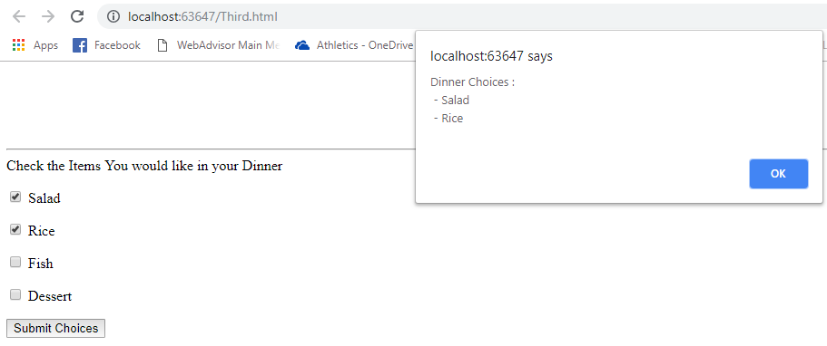

Here we can see an example of the onBlur() event. This is a good event to use because it can be very useful validating data. Blur checks the data before losing the focus from the element we are in (textbox, selections, radio buttons etc.)

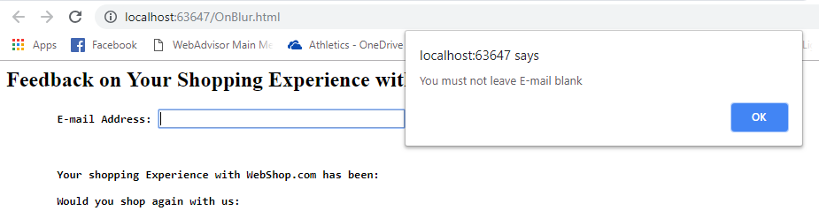

In the next example we can see how to read a string and separate it using split() function. I did some changes in this example so we can also introduce the Middle Name

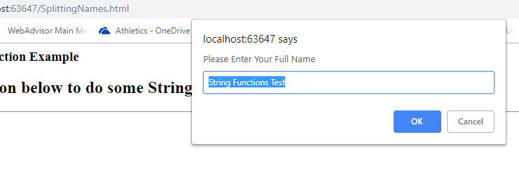

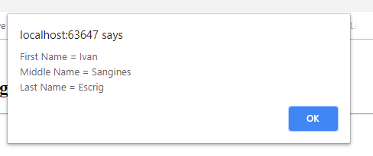

Here we can see a simple web adder where I did some changes so the result is always rounded to two decimal places using the toFixed() function.

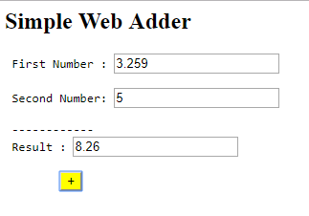

The next example is to get used to how the colors work in HTML. I changed the colors from the handout in order to see the logic behind it.

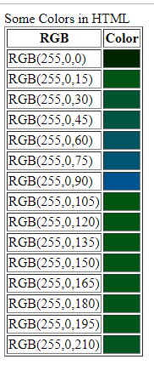

On the following example we can see how to upload a file in our website in order to obtain information about the location of it. This is achieved by using Jquery commands.

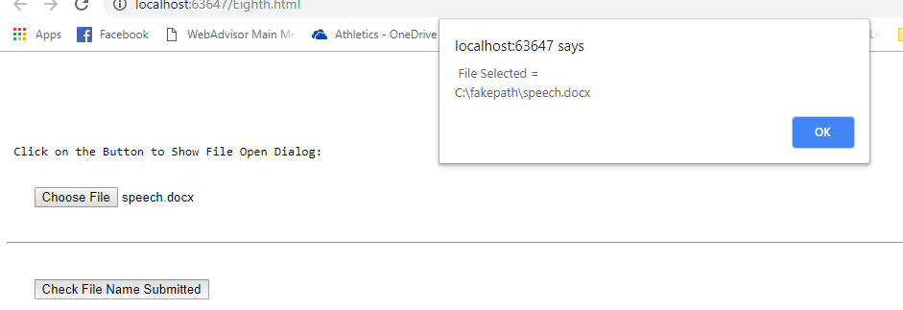

The next example is an easy one to understand better how are related the different elements of a website. The event shown in the screenshots is called bubbled, it happens whenever one element of the website is in a different element. In this case, we have a button which is inside of a form. Whenever we click on the button, the click is detected on the button and once the click event for the button is released, the click event is bubbled to the form.

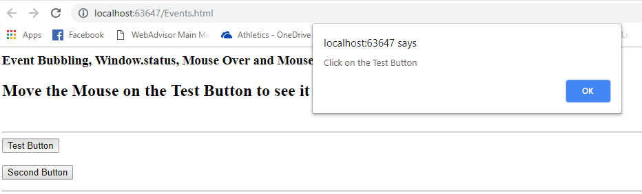

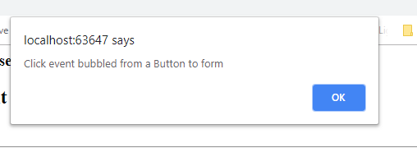

On the next example, we can see how we can use images (already uploaded on the project or with the correct URL) as simple buttons and even obtain information about them.

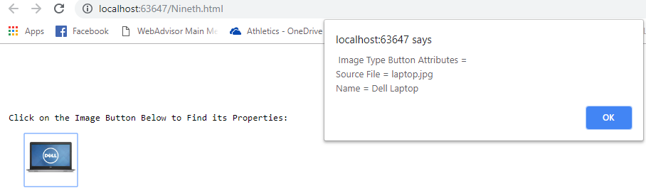

On one of the last examples, we can see how a webpage is more than just a simple form. A webpage can have different levels and elements.

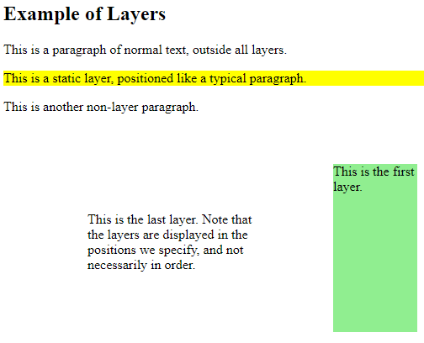

**Exercise 1:**

On this screenshot we can see the Calculator webpage we were asked to create. In order to design it, I used a table and created a style.css page. In the style.css I have declared the general format for the different elements (table, inputs, textbox).

On the HTML page is where I have created the logic in order to do the different operations using JQuerry. Also, I changed the color of some buttons and the texBox in order to get used to HTML. The result is formatted in a way that will always round up to three decimal places.

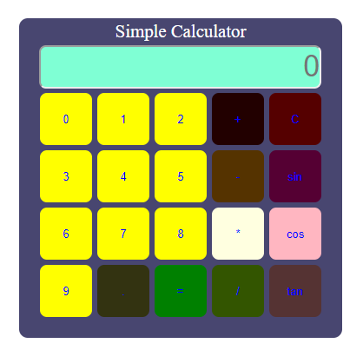

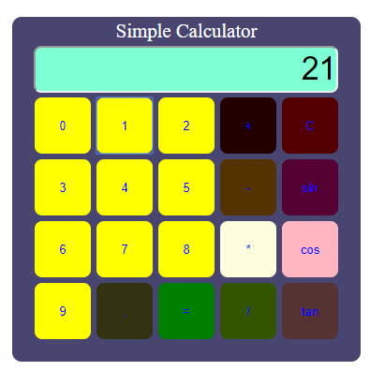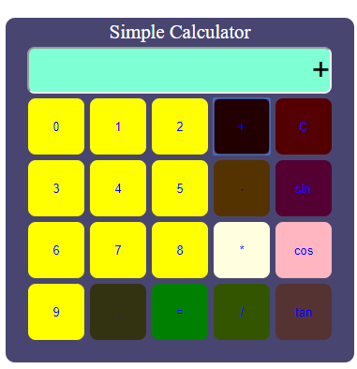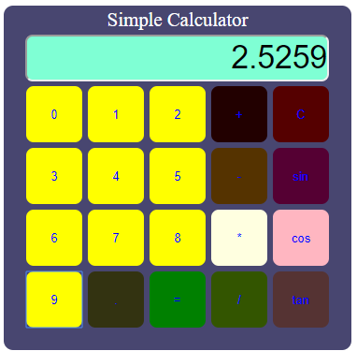

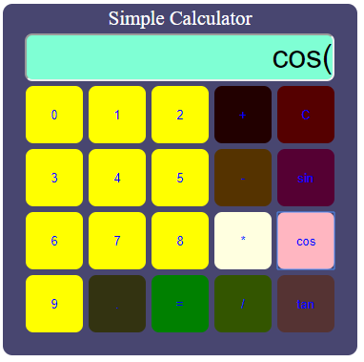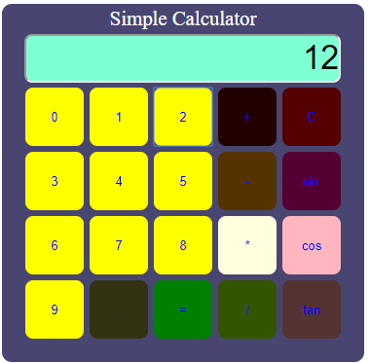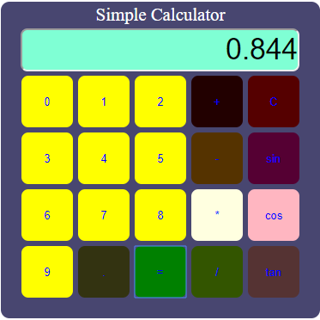

**SOURCE CODE:**

**Exercise 1:**

**HTML PAGE:**

<!-- An example of a simple Calculator -->

<html>

<head>

<title> Simple Calculator </title>

<link href="style.css" rel="stylesheet" type="text/css" />

<script src="Scripts/jquery-2.2.3.js"></script>

<script type="text/javascript">

$(document).ready(function () {

var firstNum = "";

isFirst = true;

isSecond = false;

firstTime = true;

firstOp = true;

notDec = false;

isSpecial = false;

var operand = "";

var secondNum = "";

var expresion = "";

var result = 0;

function reset() {

firstNum = "";

isFirst = true;

isSpecial = false;

isSecond = false;

notDec = false;

firstTime = true;

firstOp = true;

operand = "";

secondNum = "";

expresion = "";

result = 0;

}

$(".calc-btn").on("click", function () {

if ($(this).attr("data-role") == "number") { //Checking if it is a number

if (isFirst) {

if (firstTime || firstNum == "0") { //Checking if the first number clicked is 0

firstTime = false;

firstNum = $(this).attr("value");

$("#Display").val(firstNum);

} else {

firstNum = firstNum + $(this).attr("value");

$("#Display").val(firstNum);

}

expresion = $("#Display").val();

}

else {

if (firstTime || secondNum == "0") { //Checking if the first number clicked is 0

firstTime = false;

secondNum = $(this).attr("value");

$("#Display").val(secondNum);

if (secondNum != "0") { expresion += secondNum;}

} else {

secondNum = secondNum + $(this).attr("value");

$("#Display").val(secondNum);

expresion += $(this).attr("value");

}

}

}

else if (($(this).attr("data-role")) == "dec") { // cheking if we will operate with decimals numbers

if (notDec == false) { //cheking if "." has been pressed

notDec = true;

if (isFirst) {

firstTime = false; //in case we do not set the 0 infront of decimal

firstNum += $(this).attr("value");

$("#Display").val(firstNum);

//expresion = $("#Display").val();

}

else {

firstTime = false; //in case we do not set the 0 infront of decimal

secondNum += $(this).attr("value");

$("#Display").val(secondNum);

expresion += $(this).attr("value");

}

}

}

else {

operand = $(this).attr("value");

if (operand == "cos" || operand == "sin" || operand == "tan") { //these operands can be used without firstNum

if (firstNum == "") {

$("#Display").val(operand + "(");

expresion = operand + "(";

isSpecial = true;

isFirst = false;

}

else { //case when we have first number and we try to use sin, cos or tan which is not the proper operator

return;

}

}

else if (firstNum != "") { //making sure we have a first number

if (firstOp) { //first time we click an operand

firstOp = false;

notDec = false;

firstTime = true;

isFirst = false;

isSecond = true;

$("#Display").val(operand);

expresion += operand;

}

else { //in case we want to change the operand already selected

expresion = expresion.replace(/.$/, operand);

$("#Display").val(operand);

}

}

else {

return;

}

}

});

$(".clear-btn").on("click", function () {

$("#Display").val("0");

reset();

});

$(".calculate-btn").on("click", function () {

if (isSpecial) {

var number = "("+$("#Display").val();

expresion = "Math." + operand + number + ")";

result = (eval(expresion)).toFixed(3);

expresion = result.toString();

$("#Display").val(expresion);

reset();

} else {

result = (eval(expresion)).toFixed(3);

expresion = result.toString();

$("#Display").val(expresion);

reset();

}

});

});

</script>

</head>

<body>

<table>

<tr>

<td colspan="5" class="heading">

Simple Calculator

</td>

</tr>

<tr>

<td colspan="5"><input type="text" id="Display" placeholder="0" style="background-color:aquamarine" readonly /> </td>

</tr>

<tr>

<td><input type="button" class="calc-btn" data-role="number" value="0" /> </td>

<td><input type="button" class="calc-btn" data-role="number" value="1" /> </td>

<td><input type="button" class="calc-btn" data-role="number" value="2" /> </td>

<td><input type="button" class="calc-btn" data-role="operator" style="background-color:#220000"value="+" /> </td>

<td><input type="button" class="clear-btn" style="background-color:#550000" value="C" /> </td>

</tr>

<tr>

<td><input type="button" class="calc-btn" data-role="number" value="3" /> </td>

<td><input type="button" class="calc-btn" data-role="number" value="4" /> </td>

<td><input type="button" class="calc-btn" data-role="number" value="5" /> </td>

<td><input type="button" class="calc-btn" data-role="operator" style="background-color:#553300" value="-" /> </td>

<td><input type="button" class="calc-btn" data-role="operator" style="background-color:#550033" value="sin" /> </td>

</tr>

<tr>

<td><input type="button" class="calc-btn" data-role="number" value="6" /> </td>

<td><input type="button" class="calc-btn" data-role="number" value="7" /> </td>

<td><input type="button" class="calc-btn" data-role="number" value="8" /> </td>

<td><input type="button" class="calc-btn" data-role="operator" style="background-color:lightyellow" value="*" /> </td>

<td><input type="button" class="calc-btn" data-role="operator" style="background-color:lightpink" value="cos" /> </td>

</tr>

<tr>

<td><input type="button" class="calc-btn" data-role="number" value="9" /> </td>

<td><input type="button" class="calc-btn" data-role="dec" style="background-color:#333311" value="." /> </td>

<td><input type="button" class="calculate-btn" value="=" style="background-color:green"/> </td>

<td><input type="button" class="calc-btn" data-role="operator" style="background-color:#335500" value="/" /> </td>

<td><input type="button" class="calc-btn" data-role="operator" style="background-color:#553333" value="tan" /> </td>

</tr>

</table>

</body>

</html>

**STYLE.CSS**

table{

width: 310px;

margin: 50px auto;

background : #484670;

border: none;

border-radius: 10px;

padding: 0px 20px 20px;

}

.heading{

color: white;

font-size: 130%;

text-align: center;

}

#Display {

width: 325px;

height: 50px;

border-radius: 8px;

font-size: 210%;

text-align: right;

}

.calc-btn, .calculate-btn, .clear-btn {

height: 60px;

width: 60px;

color: blue;

background: yellow;

margin: 1px;

border-radius: 8px;

border: none;

}

**Conclusion:**

After doing this assignment I was able to practice different attributes about HTML. Reading and doing all the examples from the handout helped me to understand better how HTML works. I didn’t just learned more about HTML but I also started to understand how JQuery works as well as css code.